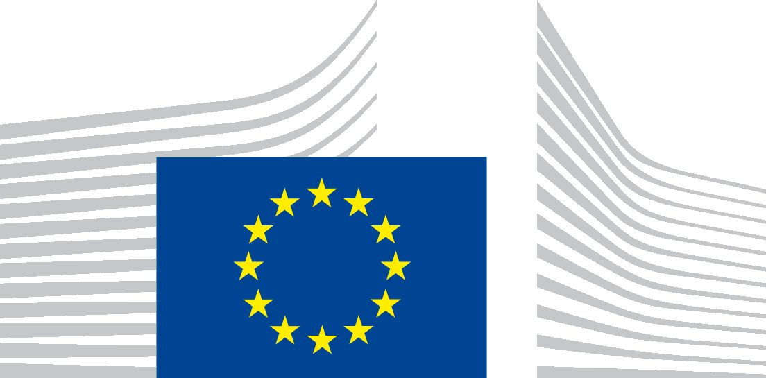 | EUROPEAN COMMISSION  DIRECTORATE-GENERAL FOR MOBILITY AND TRANSPORT  Directorate B - Investment, Innovative & Sustainable Transport  B.2 - Transport Investment
Data Protection Notice
for processing personal data within the framework of the implementation of the
Connecting Europe Facility – Transport sector programme
- Introduction
This notice concerns the collection by the European Commission's Directorate-General for Transport (DG MOVE), for publication on the website of the European Climate, Infrastructure and Environment Executive Agency (CINEA), of personal data of certain EU Member State officials. This personal data concerns in particular names and contact details of such officials. The officials in question are those who have been appointed by their administrations as contact persons for the implementation of the Connecting Europe Facility (CEF) – Transport sector programme and who, for that purpose, have given their consent to the processing of such data (hereafter 'data subjects').
This notice explains the reason for the processing, the way DG MOVE collects, handles and ensures protection of all personal data provided, how that information is used and what rights the data subjects may exercise in relation to their data (the right to access, rectify, erase, object etc.).
The European institutions and bodies are committed to protecting and respecting your privacy. The processing of personal data covered by the present notice is subject to and in accordance with Regulation (EU) 2018/1725 on the handling of personal data by EU institutions and other EU bodies.
- Why do we process personal data?
Purpose of the processing operation:
Under article 11(6) of the CEF Regulation, international organisations, joint undertakings and public or private undertakings or bodies, including regional or local authorities, may submit project proposals in the context of a CEF call for proposals subject to agreement of the Member State(s) concerned.
Member State agreement is provided by means of a supporting document to be uploaded with the application.
In order for potential applicants to become familiar with the national validation process (procedure, internal deadlines etc) and obtain any other general information about participation in the call, it is important that they are informed about the persons which they can contact in each Member State.
To this end, DG MOVE, being the Controller of this processing, and the European Climate, Infrastructure and Environment Executive Agency (CINEA), which is acting as Processor on behalf of DG MOVE, make available on the CINEA web-page of each CEF Transport call for proposals a list of Member States' contact persons.
Lawfulness of the processing operation:
The processing operations of personal data concerning the publication of the list of Member State contact persons in the context of the CEF Transport calls for proposals are necessary and lawful under Regulation (EU) 2018/1725.
The legal basis of the processing are:
- The CEF Regulation;
- The Commission Implementing Decision establishing the Executive Agencies.
Processing is necessary for the performance of a task carried out in the public interest, notably the implementation of the CEF Transport programme. It is therefore lawful under Article 5.1(a) of Regulation (EU) 2018/1725.
The data subject has given his / her unambiguous prior consent for the publication of such personal data (Article 5.1(d) of Regulation (EU) 2018/1725. The consent has been provided to the Controller before the publication and recorded in a written form.
- Which data do we collect and process?
The personal data collected and further processed are the minimum necessary in order to facilitate the identification of the data subject by potential applicants to CEF-Transport grants, such as:
- Name;
- Member State;
- Function;
- Ministry / administration and respective department;
- Contact details (e-mail address, telephone number, fax number and postal address).
These personal data are provided by the data subject on a voluntary basis, following appointment by his / her administration, by replying to a specific request of DG MOVE.
- How long do we keep personal data?
DG MOVE and CINEA will keep the data as long as the data subject is his / her Member State contact person for the implementation of the CEF Transport calls for proposals. Should he / she cease being such contact person, the data will be erased from the CINEA web-site as soon as possible but at the latest within 5 working days upon notification by DG MOVE to CINEA of this information (see point 7 below). This data will also be erased from this website when no more calls for proposals under the CEF Programme will be launched (31/12/2027) in view of the completion of the multiannual financial framework for 2021-2027.
- How do we protect personal data?
All data in electronic format (e-mails, documents, uploaded batches of data etc.) are stored on the servers of the European Commission (DG MOVE and CINEA), the operations of which abide by Commission Decision (EU, Euratom) 2017/46 of 10 January 2017 on the security of communication and information systems in the European Commission.
- Who has access to personal data and to whom is it disclosed?
The personal data mentioned under point 3 above will be published in the CINEA web-site (https://cinea.ec.europa.eu/calls-proposals/2021-cef-transport-call-proposals_en) and will therefore be publicly accessible. In view of the scope of the processing, the main recipients of the data are expected to be the applicants to the CEF funding in the field of transport.
- What are the data subject's rights and how can he / she exercise them?
According to Regulation (EU) 2018/1725, the data subject is entitled at any time to access his / her personal data and rectify it in case the data is inaccurate or incomplete as well as to erase it. The data subject is also entitled to object to the processing of his/her personal data.
This can be done by sending an e-mail to the data controller (see point 8 below) via the following functional mailbox: MOVE-B2-CEF-COMMITTEE@ec.europa.eu.
In the same way, in case the data subject no longer is the appointed contact person, this will imply the deletion of his / her personal data from the CINEA web-site and from any related records of the controller.
In any cases, the data will be modified or removed accordingly and as soon as practicable (maximum within 5 working days) by the processor (CINEA) after having received the relevant information from the controller.
The data subject can exercise his / her rights by contacting the data controller, or in case of conflict the Data Protection Officer of the European Commission and if necessary the European Data Protection Supervisor using the contact information given at point 8 below.
- Contact information
If data subjects have comments or questions, any concerns or a complaint regarding the collection and use of their personal data, they may contact the Data Controller using the following contact information:
The Data Controller:
Directorate-General for Mobility and Transport (DG MOVE)
Unit B.2 'Transport Investment'
Email: MOVE-B2-CEF-COMMITTEE@ec.europa.eu
The Data Protection Officer (DPO) of the Commission: DATA-PROTECTION-OFFICER@ec.europa.eu
The European Data Protection Supervisor (EDPS) to lodge a complaint: edps@edps.europa.eu.

Regulation (EU) 2018/1725 of the European Parliament and of the Council of 23 October 2018 on the protection of natural persons with regard to the processing of personal data by the Union institutions, bodies, offices and agencies and on the free movement of such data, and repealing Regulation (EC) No 45/2001 and Decision No 1247/2002/EC, (OJ L 295/2018 of 21/11/2018, p. 39).
Regulation (EU) No 2021/1153 of the European Parliament and of the Council of 7 July 2021 establishing the Connecting Europe Facility and repealing Regulations (EU) No 1316/2013 and (EU) No 283/2014 (OJ L 249 of 14/7/2021, p. 38)
See footnote N°2.
Commission Implementing Decision (EU) 2021/173 of 12 February 2021 establishing the European Climate, Infrastructure and Environment Executive Agency, the European Health and Digital Executive Agency, the European Research Executive Agency, the European Innovation Council and SMEs Executive Agency, the European Research Council Executive Agency, and the European Education and Culture Executive Agency and repealing Implementing Decisions 2013/801/EU, 2013/771/EU, 2013/778/EU, 2013/779/EU, 2013/776/EU and 2013/770/EU (OJ L 50, 15.2.2021, p. 9).

