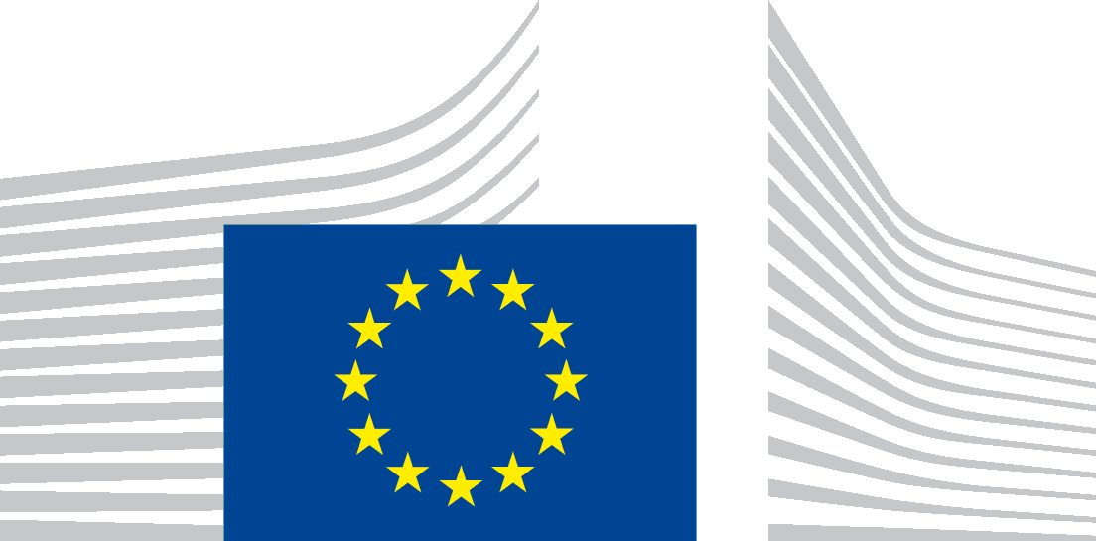 | EUROPEAN CLIMATE, INFRASTRUCTURE AND  ENVIRONMENT EXECUTIVE AGENCY (CINEA)  CINEA.D - Natural resources, climate, sustainable blue economy and clean energy  D.2 - LIFE Environment (Nature & Circular Economy)

LIFE 2020 NGO4GD Grants
Grant Agreement Technical Report
Covering the period xx/xx/xx-xx/xx/xx
To be submitted within three months after the project end date to:
CINEA-LIFE-MONITORING@ec.europa.eu
Beneficiary name and acronym:
Proposal acronym
Grant agreement number | LIFE20/NGO4GD/XXXXXXXXXXXXXXXX
Person responsible:
(please provide full contact details)
Date of compilation:

Budget implementation:

 | WP1 | WP2 | WP3 | WP4 | WP5 | TOTAL
Lump sum amount as per GA (in EUR)
Lump sum share per WP as per GA | % | % | % | % | % | %
% implementation | % | % | % | % | % | %

Notes regarding this form:
- All activities are implemented during the reporting period
- Please send supporting documents (evidence material) such as brochures, publications, reports or any other deliverables produced during the reporting period only electronically, through a separate folder. If the documentation is too heavy, it can be sent via wetransfer or through a shared dropbox folder. Please provide links to the documents available online.

- SUMMARY OF THE IMPLEMENTATION OF THE INTERVENTION
(1-2 pages)

Please give a general overview referring to Annex II of the GA based on the following:

- Objectives – please assess how well the objectives were met in general. This should include an assessment of how needs identified in the application form where addressed.
- Activities– give a summary description of the main activities carried out.
- Deviations/Unforeseen actions – if relevant, please state which planned activities were replaced or not carried out and/or which expected results were not achieved, in part or in full, and provide the main reasons why. Please also describe if new unforeseen actions were developed and implemented during the eligibility period.
- Results and impacts – give a summary description of the results achieved providing quantitative and qualitative data, including deliverables and impacts as specified in the GA.
- Effectiveness and lessons learned – please give your assessment of the overall effectiveness of the work carried out. If relevant, please indicate areas that could be improved, lessons learned and pointers for future work.

- HIGHLIGHTS

Describe shortly 1-3 activities that can be put forward as particularly successful and where you consider that your work had the highest impact.

- DETAILED ACTIVITIES AND RESULTS/IMPACTS UNDER EACH WORK PACKAGE

Instructions for filling in the form

The report form follows the structure of the technical application form.

In the first row, please tick the boxes to give a general appreciation of how well the activities were carried out in the respective work package.

Secondly, please fill in the following:

Objectives
Based on the objectives listed in your application, please describe the results and indicate if the objectives were achieved fully, partly or not at all. If an objective was not fully achieved, please state the reason why. See also section 4 above (Deviations).

Activities
Based on the activities listed in your application, please give a description of how they were carried out. For each activity, indicate if it was carried out fully, partly or not at all. If it was not fully carried out, please give the reasons why.

Results and impacts
Based on the expected results listed in your application, please give a description of the results achieved for each activity:
- Deliverables/immediate outputs;
- medium-term results (outcomes); and
- impacts (long-term results).

Provide qualitative and quantitative information on the actual level of achieved results. For each result, please indicate if it was achieved fully, partly or not at all. If it was not fully achieved, please give the reasons why.

Please describe how the continuation/valorisation of results achieved will be ensured. Please identify which results/actions are particularly suited for transfer to/ replication by other actors. When applicable, identify such actors and what was done to inform/mobilise them.

Evidence
Please list here all evidence material (contributions to consultations, reports, minutes, books, booklets, CDs etc.) and link them clearly with the results and activities. Indicate how/where the material can be accessed and consulted. If it is available on a website, please give the link.
____________________________________________________________________________

Work Package 1: [Name, e.g. Awareness Campaign]

The activities in this area have been carried out

Fully Mainly Partially Limited

Duration:

Objectives:

Activities:

Results – please link results with the corresponding objectives:

Deliverables/evidence – please link activities with the corresponding deliverables/evidence:

Work Package 2: [Name]

The activities in this area have been carried out

Fully Mainly Partially Limited

Duration:

Objectives:

Activities:

Results – please link results with the corresponding objectives:

Deliverables/evidence – please link activities with the corresponding deliverables/evidence:

- OTHER COMMENTS

Optional: please give here any further relevant information that could not be provided elsewhere .

Declaration of the beneficiary:
I, the undersigned, declare that the information contained in the present report is correct and consistent with the facts.

Name:
Title or function:
Tel:
E-mail:

Signature:
Date:

