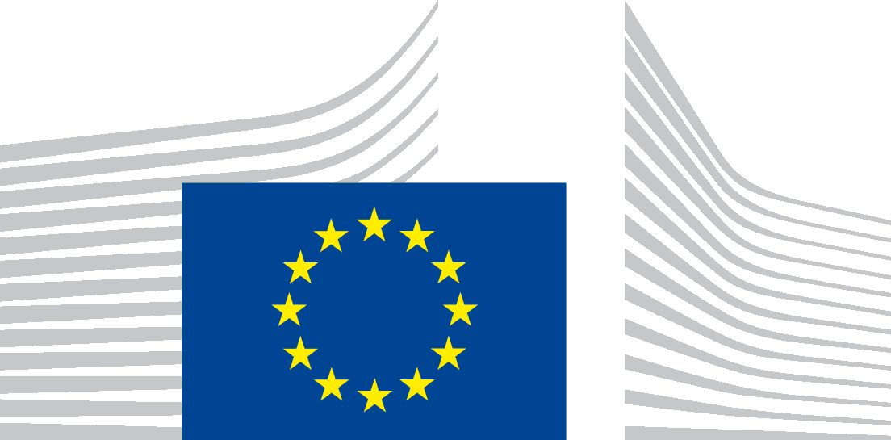 | EUROPEAN CLIMATE, INFRASTRUCTURE AND  ENVIRONMENT EXECUTIVE AGENCY (CINEA)  CINEA.D - Natural resources, climate, sustainable blue economy and clean energy  D.3 - Sustainable Blue Economy

Agreement CINEA/EMFF/year/Action number/xxxx
Project full name

European Maritime and Fisheries Fund (EMFF)
Progress Report
(maximum 2 pages)
Progress Report Number:
Covered period:
Project duration: from to
Date of submission:
Version:
Beneficiary
(or coordinator organisation in case of multiple beneficiaries):
Project coordinator name and title:
Tel.:
E-mail:
- Progress of work plan in the covered period
  - General progress:

Summarise the objectives and the achievements, deviations, important problems and difficulties met.
  - Progress on the project against initial general and specific objectives:

Compare the activities planned (based on the Grant Agreement and/or the previous report) to the progress made, by specific objective and according the agreed work plan in the initial proposal (Annex I of the Grant Agreement); list achieved deliverables and identify partners involved, including their roles; describe major subcontractors and other stakeholders involved.
  - Identified deviations, problems and corrective actions taken in the period:

If any, identify the nature and the reason for the deviation or encountered problems (technical, financial or organisational), identify partners involved, clarify impacts on the activities and deliverables, present the strategy to overcome them; in case of deviations described in the last report describe to which extent you have managed to get back on track.

- Work plan for the next period
  - Planned activities in the next reporting period:
Give an outlook on planned activities and deliverables, for the period until the next report, according to the agreed work plan in the initial proposal (Annex I of the Grant Agreement).

- Other issues

If any, indicate other project-related issues to be brought to the attention of the CINEA and/or the European Commission.

